Project Report Template

**1.INTRODUCTION**

**1.1 Overview**

Unlocking Insights into the global air transportation network is a complex web of airlines, airports, routes, and passenger flows that connect people and goods across the world. This network involves analysing data on flight routes, passenger demographics, cargo shipments, and airline operations. By doing so, researchers and analysts can gain valuable information about travel trends, connectivity, environmental impacts, and economic implications, ultimately helping to improve the efficiency and sustainability of air travel on a global scale.

**1.2 Purpose**

The global network's primary purpose is to connect people, devices, and information worldwide, enabling communication, information exchange, commerce, education, social interaction, and more. It serves as the backbone of our interconnected digital society, driving innovation and collaboration on a global**.**

**2.PROBLEM DEFINITION & DESIGN THINKING**

**2.1 Empathy Map**

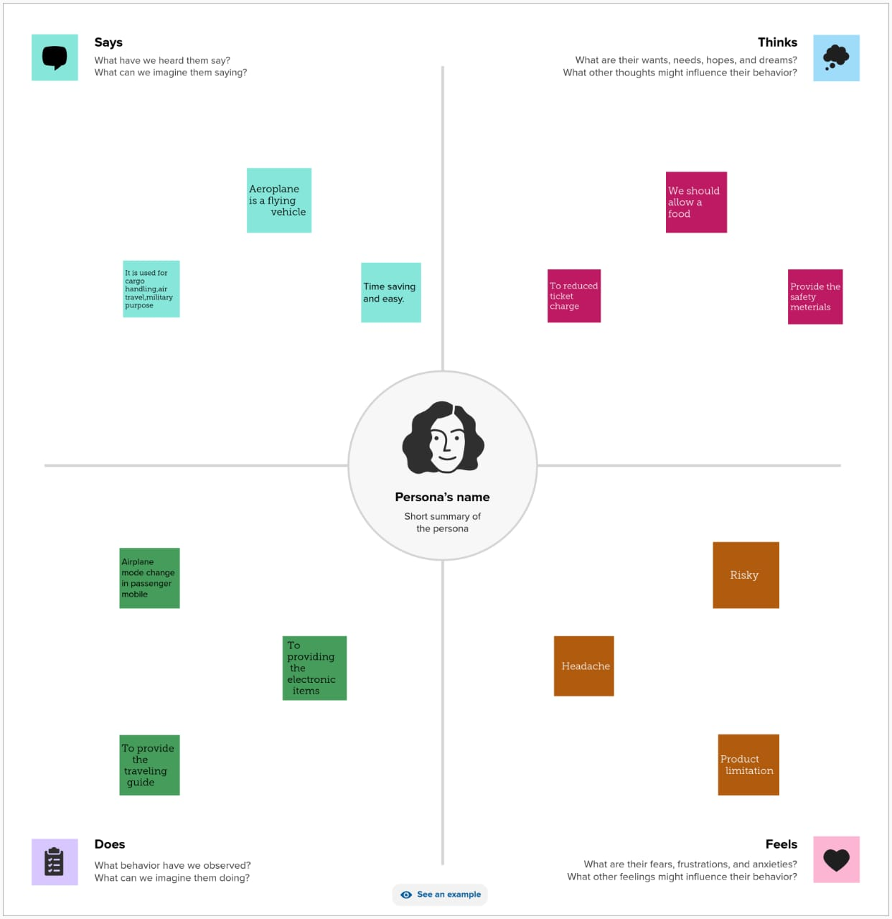

**2.2 Ideation& Brainstorming Map**

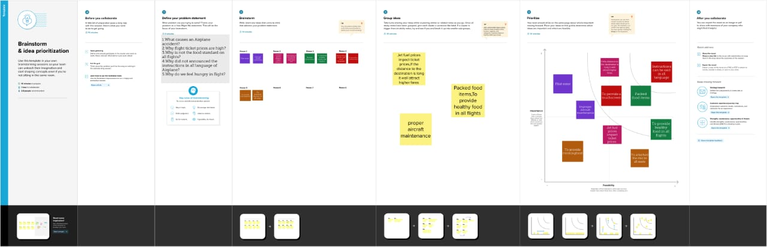

**3.RESULT**

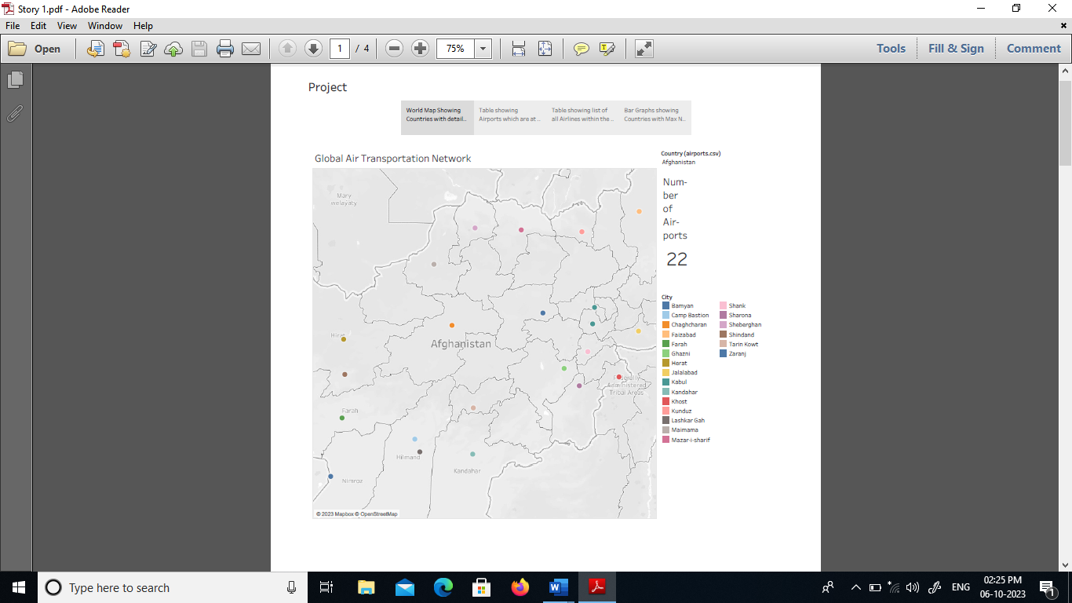

**4.ADVANTAGES**

* . It allows pilots and passengers to stay connected to the internet and communicate with people on the ground while flying.
* . The infrastructure required to establish this service could be higher. .Transportation at high speeds.
* . Air transport generates a total of 13.5 million jobs

(direct, indirect and induced). Of these, 5 million are direct jobs.

Disadvantages

* More costly than other modes of transportation .
* .Unsuitable for cheap, large items as transport costs may exceed the cost of the items.
* Limited capability for moving people or goods.

5.APPLICATIONS

Unlocking insight into the global air transportation network allows us to understand how airlines, airports, and routes are interconnected worldwide. It helps us analyze trends, optimize operations, and improve efficiency in the aviation industry. It's like having a bird's-eye view of the entire global air transportation system.

6.CONCLUSION

In conclusion, "Unlocking Insight into the Global Air Transportation Network" is an invaluable application for anyone interested in air travel. It provides comprehensive data and analysis, helping users make informed decisions, understand industry dynamics, and enhance their aviation experiences.

7.FUTURE SCORE

Looking into the future, the scope of unlocking insight into the global air transportation network is exciting! With advancements in technology and data analytics, we can expect even more sophisticated tools and strategies to optimize flight routes, improve safety measures, and enhance passenger experiences. This will lead to more efficient operations, reduced delays, and increased connectivity in the global air transportation network. The future looks bright for air travel.